Implementation of Fixed Asset System

Create new Fixed Asset Database

Step 1: Restore FA_Common and Fixed Asset Database
Launch SQL Server Management Studio and restore provided FA_Common and empty fixed asset database.

Step 2: Restore Portal File
Restore portal file to the following path. “C:\inetpub\wwwroot”

Step 3: Convert Portal to Application in IIS
Assume IIS and IIS component installed. Go to IIS manager “YOURSERVER > Sites > Default Web Site > YOUR FIXED ASSET PORTAL FILE” right click and select “Convert to Application”
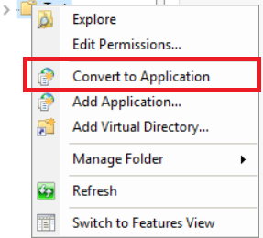

Step 4: Create Application Pool in IIS
Go to IIS manager “YOURSERVER > Application Pool” right click and select “Add Application Pool”
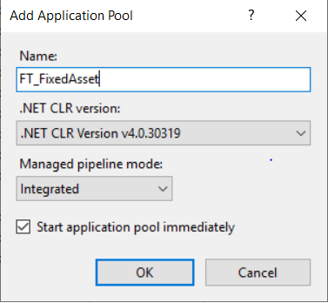

Step 5: Setting Application Pool in IIS
In the application pool list, select the Application Pool that you just added. Right click and select “Advanced Settings”
Set “Enable 32-Bit Application”: True if your SAP is using 32bit DIAPI, False if your SAP is using 64bit DIAPI
Set “Identity”: Set Admin account ID and Password.
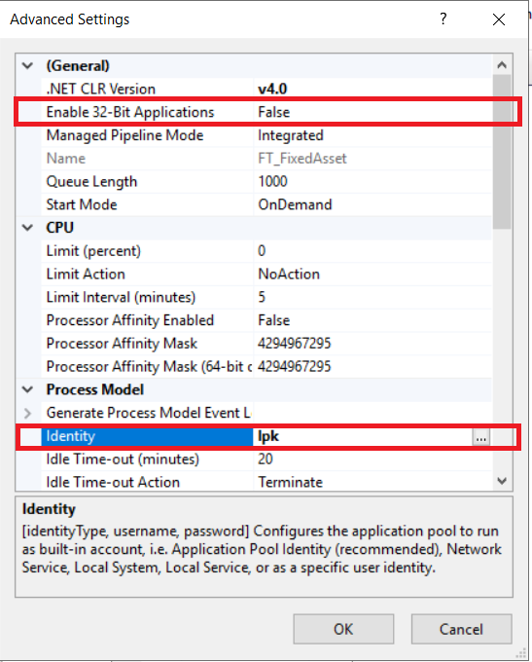

Step 6: Setting connection to Common Database
In Fixed Asset Portal file, edit “Web.Config” file, look for “ConnectionString” tag and edit the connection string accordingly to Common database.

Step 7: Create a new Fixed Asset Database
Create a new database in SQL Server, example FA_TEST.

Step 8: Restore the new Fixed Asset Database with earlier backup
Use SQL Server Management Studio to restore the new Fixed Asset Database with backup of existing Fixed Asset Database.

Step 4: Edit FA_COMMON..ODBC table to add new Fixed Asset Database
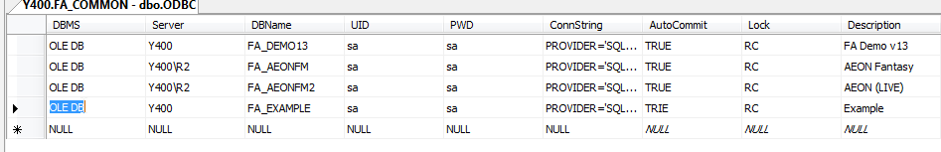

Step 9: Reset New Database using SQL Script
If you are restoring existing duplicate database, execute the following SQL Script to the new Fixed Asset Database to reset all data.
EXEC sp_FTS11_ResetDatabase

WARNING: This statement will wipe out all master data and transaction of the Fixed Asset Database. Make sure you are running the script on the new Fixed Asset Database and NOT existing database.
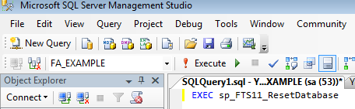

Step 10: Login new Fixed Asset Database using Administrator ID
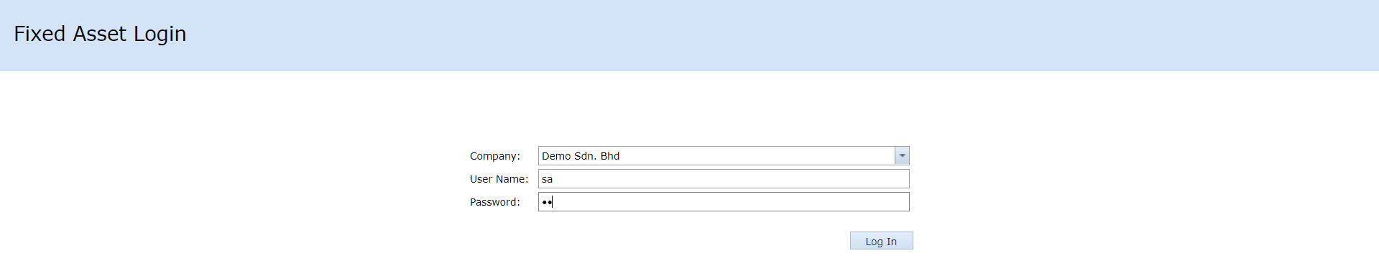

Step 11: Update General Settings
Go to System Initialization > General Settings to update the connection setting to SAP Business One and company name.


